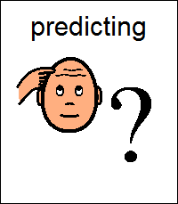  I think this painting is about… because…  I think this image shows…  because  I think the artist wants us to think…  I think the artist wants to show us… | 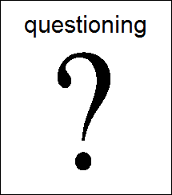  I wonder what the artist…?  Why do you think the artist…?  How do you think the artist…?  What / where / when / why / how
Colour Value  Visual Elements  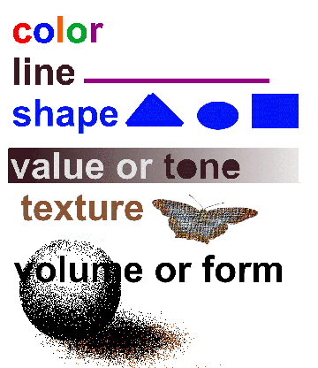  Line Texture  Shape Space  Form  I think the artist has chosen to use….because | Vocabulary bank  Colour – bright, bold, strong, vibrant, pale  Line – sketch, outline, curved, straight  Shape- abstract, geometric, freeform  Form – 2d, 3d, sculpture  Value – light, dark, shade, highlight, tone  Texture – rough, smooth, feel  Space – distance, perspective

What I like most/ least about this piece of art is…
This is because…

