1/3/16
LI to use precise vocabulary to problem solve
Useful vocabulary today might be… | Some useful problem solving phrases might be…
A great starting point is…____
_________________________
_________________________
because___________________________________________

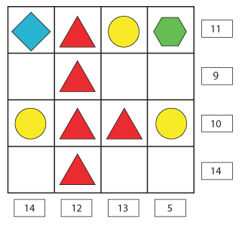
Once I found the starting point the next best place to go was…_____________________________________________because___________________________________________
_________________________

Convince Chloe…
I know that _______ must be_______________because____________________________________
__________________________________________________________________________________
This means that _________ must be ______________________because_______________________
__________________________________________________________________________________
__________________________________________________________________________________

