Early Career Professional Development Programme

**Welcome Pack for early career teachers**

National Roll Out of the  
Early Career Framework

## Handbook for Delivery Partners

# Contents

Foreword 3

1 Your learning journey 4

1.1 What will you get from this? 4

1.2 What will you be doing? 5

1.3 How is the learning structured? 6

1.4 How will the Programme materials work for you? 6

1.5 What is the online platform for? 7

2 Mentoring support 8

2.1 Your mentor 8

2.2 Instructional Coaching from your mentor 8

2.3 Using IRIS Connect together 9

3 Your wellbeing 10

4 Your schedule 11

5 Your point of contact 11

6 Get started, get inspired! 12

# Foreword

We are delighted you have joined with us to take part in the Early Career Professional Development Programme and would like to take this opportunity to welcome you to a career in teaching. Education Development Trust is one of six organisations appointed by the Department for Education to deliver a funded package of support to early career teachers (ECTs). This package is a brand-new entitlement to strengthen your induction experience and give you dedicated time and support to develop and thrive in your chosen profession.

Education Development Trust is an international charity which aims to transform children’s life chances by improving education around the world. We have a strong track record in leading national initiatives here in England and are known as an organisation which is dedicated to school-led delivery and collaborative school improvement, working *with* schools *for* schools. On the Early Career Framework, we are partnering with Teaching School Hubs, multi-academy trusts and other school-groups across the country, as our Delivery Partners. This means that the training you receive has been designed centrally by a wide group of experts from schools, universities, and other organisations, and will be quality assured nationally. However, it will be delivered by local practitioners, who you will get to know, and who understand the unique needs of the school where you will start your career. This Delivery Partner will be your main point of contact with the Programme, and will work with you, your mentor, and your school more widely to help support you throughout your time as an early career teacher.

The first years of teaching are both a time of challenge and when you experience the greatest growth as a professional. This Programme has been designed to meet your full learning and development needs as an early career teacher, to build up a network of experienced support around you, and to enable you to meet and learn from your peers, who will be just as keen as you are to share ideas and successes and overcome obstacles together.

We will be with you every step of the way, and hope you are looking forward to this journey as much as we are.

**Matt Davis**

**UK Regional Director**

**Education Development Trust**

# 1 Your learning journey

## 1.1 what will you get from this?

* There is a lot to learn at the start of any career. This new two-year programme of support is designed to make sure you can focus on the things that will make the most difference in the classroom and your professional practice.
* [](https://www.bell-foundation.org.uk/)[](https://www.shu.ac.uk/about-us/academic-departments/institute-of-education)Our evidence-led programme of training was co-created with the teacher-educators at [Sheffield Institute of Education](https://www.shu.ac.uk/about-us/academic-departments/institute-of-education) (Sheffield Hallam University), with support from English as an Additional Language specialists [The Bell Foundation](https://www.bell-foundation.org.uk/), and many expert inputs from the fields of SEND and Early Years.
* The Programme is designed around what really works, and how people really learn, teaching you skills you can use straight away.
* You will be supported throughout by a fully trained mentor, as well as engaging in flexible, bite-sized online learning, and benefiting from face-to-face and virtual training delivered by school-based experts.
* All this will enable you to:
* build a deep understanding of the knowledge and know-how which makes up the Early Career Framework
* explore the evidence behind education research and implications for classroom teachers
* develop your teaching through practical ideas and exemplifications of the research in practice
* reflect on your development, identify areas of strength and areas for improvement, supported 1:1 by your mentor
* engage in collaborative learning, sharing of best practice and expert challenge with a community of other early career teachers

This is what some of the early career teachers said about the 2020-2021 pilot:

“I loved that it was interactive with breakout groups and being able to share with other teachers, rather than just sitting and listening. This made it much more engaging.”

“This is a well-timed training course and it has given me a real boost and renewed my enthusiasm and confidence. Fantastic and very relevant advice. Thank you!”

“I found it most helpful every section focused on how to put the theory into practice. This is really helpful as it has shown me strategies and techniques to use within my own classroom.”

“It was interesting to hear the opinions of what experienced teachers have learned and what they wish they knew at the stage of being an NQT. I think you are sometimes given so much theory into what to aim for, but it is great to hear some stories of how this actually works (or sometimes doesn't work) in practice from some individuals who have actually tried it and learned from it.”

## 1.2 what will you be doing?

Over the two years of the Early Career Professional Development Programme, you will work through 12 Blocks (modules) in total, one per half term. Each Block has been designed based on international best practice of effective professional development and includes:

* **Self-Directed Study Materials:** Interactive self-study materials which explain the research behind the Early Career Framework and exemplifications of what this looks like in the classroom. [You will find these self-study materials as well as a wealth of other resources on the ECPDP online platform](https://www.earlycareerpdp.com/login/index.php). There is also protected time in Year 1 as part of the self-directed study to observe colleagues and to be observed.
* **Mentor Sessions:** One-to-one sessions to help you translate the research into your own practice and reflect on your learning and development.
* A picture containing rectangle

  Description automatically generated**Training Sessions:** Group sessions, delivered face-to-face, to explore the Early Career Framework with your peers. These sessions will be facilitated by an expert practitioner who will extend your thinking and support your planning by sharing practical applications of the research in your classroom.

Each Block provides you with the time to:

* **Learn** the content from the Early Career Framework
* Put the learning into **practice** with suggestions for classroom practice
* **Reflect** on your professional and personal development.

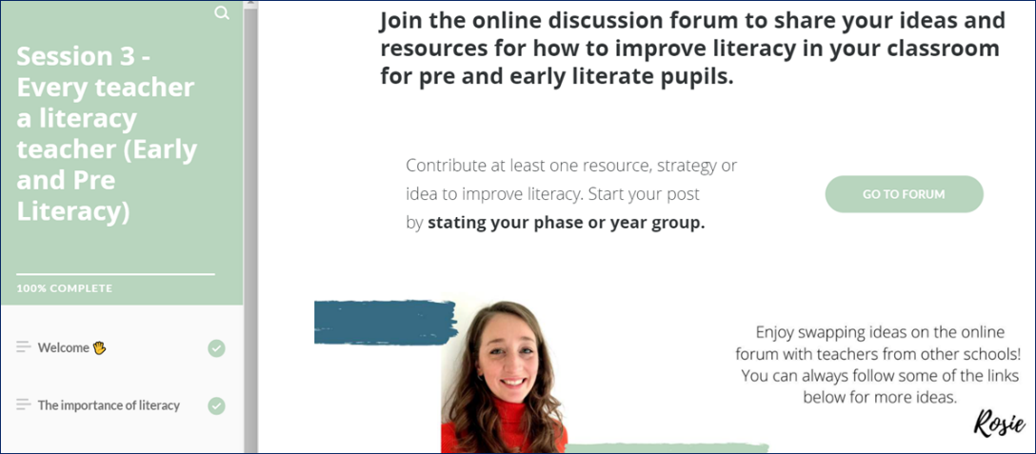

## 

## 1.3 how is the learning structured?

Each Block starts with a ‘**why this, why now?**’ summary, which states the purpose of the Block and sets it in the context of your experience, understanding and confidence. Many aspects of the Early Career Framework are interconnected (for example, quality assessment is not entirely distinct from quality planning or curriculum design). While we have maintained a specific deep focus for each Block, so that you have enough time to understand the key aspects of those statements, the Blocks do make reference to the links between different areas, and we encourage your mentor and facilitators to support the contextualisation and inter-linking as well.

|  |  |
| --- | --- |
| **Block 1:** Establishing a positive climate for learning | **Block 7:** Embedding a positive climate for learning |
| **Block 2:** How pupils learn: memory & cognition | **Block 8:** How pupils learn: making it stick |
| **Block 3:** Developing effective classroom practice: teaching & adapting | **Block 9:** Enhancing classroom practice: grouping & tailoring |
| **Block 4:** The importance of subject & curriculum knowledge | **Block 10:** Revisiting the importance of subject & curriculum knowledge |
| **Block 5:** Assessment, feedback & questioning | **Block 11:** Deepening assessment, feedback & questioning |
| **Block 6:** A people profession | **Block 12:** Continuing your professional development |

[Click here for the full details of each Block](https://www.educationdevelopmenttrust.com/EducationDevelopmentTrust/files/9c/9cbc071f-8014-4907-b7ad-def6fa565f28.pdf).

Our sequence is designed based on best practice of interleaving and spaced practice for knowledge retention and recall. Each Block in Year 1 is revisited and developed in Year 2. This gives you the opportunity to build on the learning from Year 1 as well as identify and recognise, through the support of your mentor, the extent to which you have mastered each aspect. Together with your mentor you will celebrate successes, recognise areas of expertise, and identify further areas and opportunities for development.

## 1.4 how will the programme materials work for you?

These materials are designed to work for all early career teachers regardless of subject, phase, or context. Exemplars have been drawn from a wide range of specialisms and phases and chosen specifically for their relatability. Even if you do not teach pupils at the particular stage the example refers to, the point being demonstrated will still be relevant.

Your mentor and facilitators of group learning sessions will all be trained on how to adapt the sessions to meet your particular needs and contextualise examples and research for your phase or subject. You should make use of their support by bringing questions, reflections, or the answers to your interactive tasks from the self-study materials to sessions with you.

## 1.5 what is the online platform for?

The online platform will enable your journey throughout the Programme and will act as the central point for Programme updates, access to self-study materials and webinars, and for you to enrol onto your training sessions.

The resources and functionalities sit within five zones: Home, Progress, Learn, Events, Explore, allowing you to:

|  |  |
| --- | --- |
| **Home** | * get the latest Programme news * pick up team messages * access your own, personalised events calendar * jump into the Block you’re working on |
| **Progress** | * check out your progress through the course materials * see how much of the current Block you’ve completed * quickly pick up from where you last finished |
| **Learn** | * find all the Blocks of core, interactive eLearning, as they go live on the platform * see at a glance where you’re up to in each Block * join in Community of Practice discussion forums |
| **Events** | * see which training events are available to you * book onto selected events, choosing the date/time best suited to you |
| **Explore** | * access core guidance, e.g. ‘getting started’, wellbeing, part-time/flexible working guides * catch up on or revisit training sessions by accessing the recordings, and download webinars * discover a range of additional resources, e.g. blogs, podcasts, research digests, videos and signposting to subject/phase/specialist associations |

**Logging in for the first time**

To log into the online platform for the first time, you will need to locate your email invitation which will be sent to you in September, or when you start the Programme. Following the instructions within this email, you will be directed to the platform to set your password and log in. Should you require any technical support with the online platform, please email [ecf@educationdevelopmenttrust.com](mailto:ecf@educationdevelopmenttrust.com).

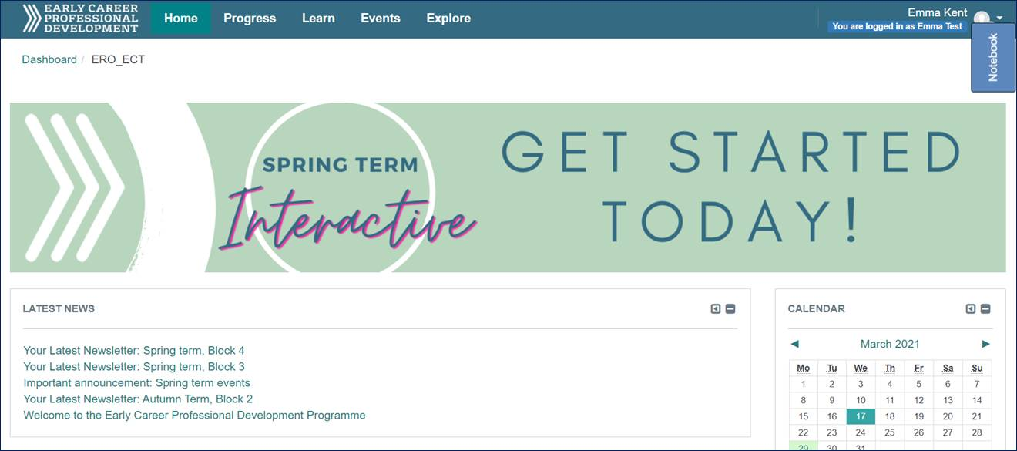

# 2 Mentoring support

## 2.1 your mentor

The relationship between you and your mentor is at the heart of the Early Career Professional Development Programme – it is what will drive the greatest improvements in your knowledge, skills, and confidence. As a Programme, we will support you to develop a constructive professional relationship with your mentor, who will provide support and challenge and be your guide through these first two years in the profession.

## 2.2 instructional coaching from your mentor

Instructional Coaching is a strongly evidenced model of support for improving teacher practice. In terms of impact on pupil outcomes it has a better evidence base than any other form of CPD ([Sims, 2019](https://samsims.education/2019/02/19/247/)), which is why all mentors on this Programme will use it as a model for working with you in your ECT-mentor sessions.

Instructional Coaching involves an expert teacher or practitioner working individually with you to support your learning at the start of your career. Not to be confused with traditional coaching and open-ended questions, Instructional Coaching is a structured cycle of identify – learn – improve. Crucially, Instructional Coaching involves revisiting the same specific skills, with bite-size feedback each time. Your mentor won’t just tell you *what* you need to improve but *how* to improve*.*

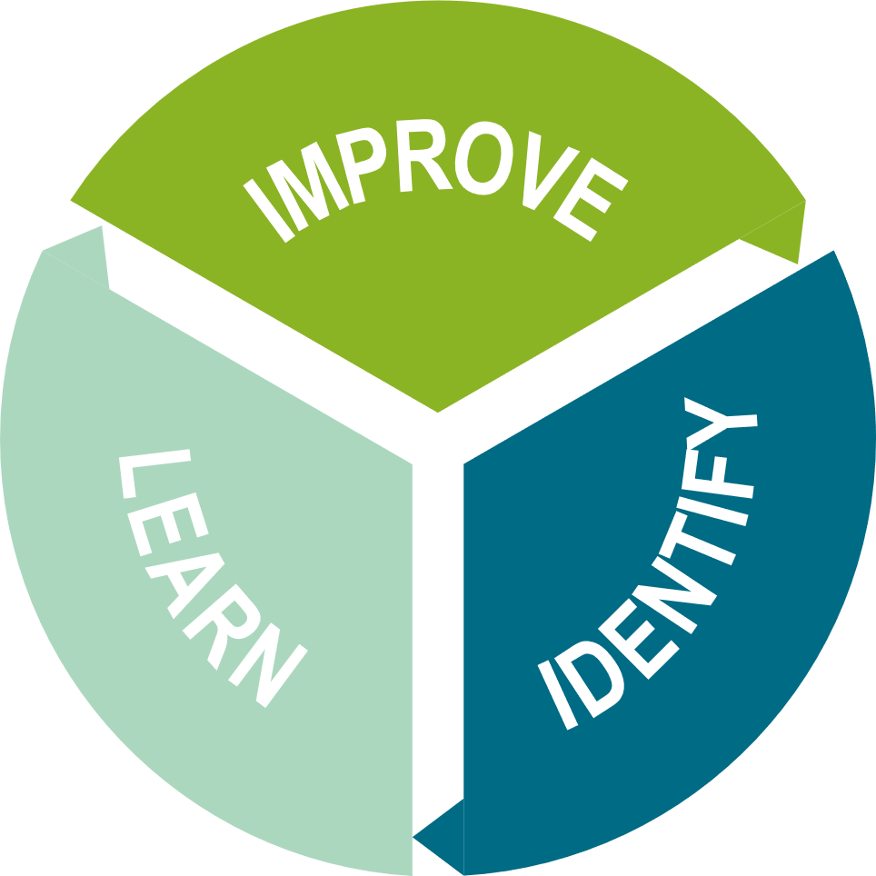

When you go back to your classroom tomorrow, what will you do differently?

Go away and do.

Monitor / review / adapt / modify / tweak

How am I going to achieve the change?

What am I going to do?

When will this be done?

Where is an example to help develop thinking further?

What am I seeing in the classroom?

What do I know we need to improve?

Where can I have the greatest impact on pupil learning?

What do I need to change to achieve this?

## 2.3 using iris connect together

The mentor-mentee partnership will be supported – if you and your mentor wish to use it – by free access to [IRIS Connect’s](https://www.irisconnect.com/uk/) video-enabled professional learning platform. This allows you and your mentor to record aspects of your classroom practice and transfer the videos securely via your personal, password-protected accounts. From there, you can reflect on your own and others’ teaching, analyse focused aspects of practice, add time-stamped comments, and share with your mentor for feedback.

Both you and your school IT administrator will receive details on how to access the platform. Any technical issues should be referred to IRIS Connect by visiting [irisconnect.com/uk/support/](https://www.irisconnect.com/uk/support/) or contacting the helpdesk:

Helpdesk by phone: 0333 136 2483

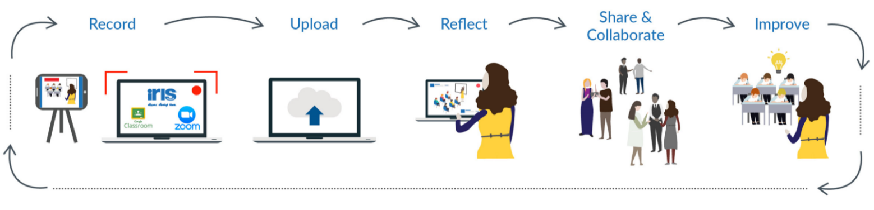Helpdesk by email: [support@irisconnect.co.uk](mailto:support@irisconnect.co.uk)

[Watch this video to hear from teachers on the gains they have made using IRIS Connect.](https://irisconnect.wistia.com/medias/rgp35dia3t)

[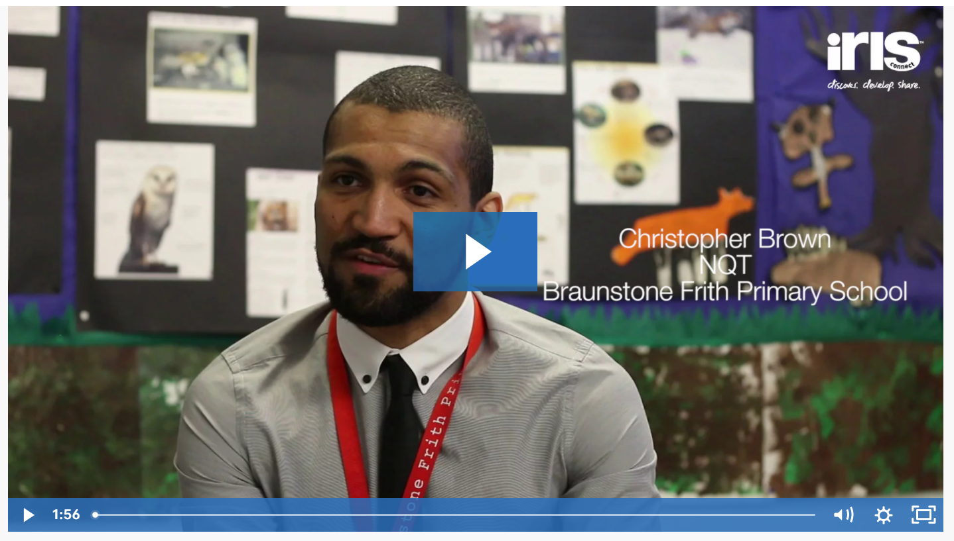](https://irisconnect.wistia.com/medias/rgp35dia3t)

# 3 Your wellbeing

Looking after yourself in your early years in the profession is vital. Throughout the Blocks we offer suggestions, drawn from the Early Career Framework, of how workload can be reduced, and wellbeing enhanced. The self-study materials are designed to take into consideration your busy professional and personal lives, and so can be accessed online at any time to support flexible learning and professional development.

The DfE upholds that the most effective actions to reduce workload are those that encourage better teaching. Each Block is designed to support you in improving your practice through:

1. Focusing on the priorities.
2. Ensuring these are supported by evidence.
3. Making the best use of your time.

This strengthened induction *will not add to your workload* and will be delivered entirely within your timetable reduction.

* You will work with your mentor who will support you on an individual basis.
* You will develop strategies to support you in establishing a sustainable and manageable work-life balance.
* You will learn strategies to support you in taking control of your own workload.

On the online platform, under **Explore**, you will find a webpage signposting you to a range of professional sources of mental health and wellbeing advice.



# 4 Your schedule

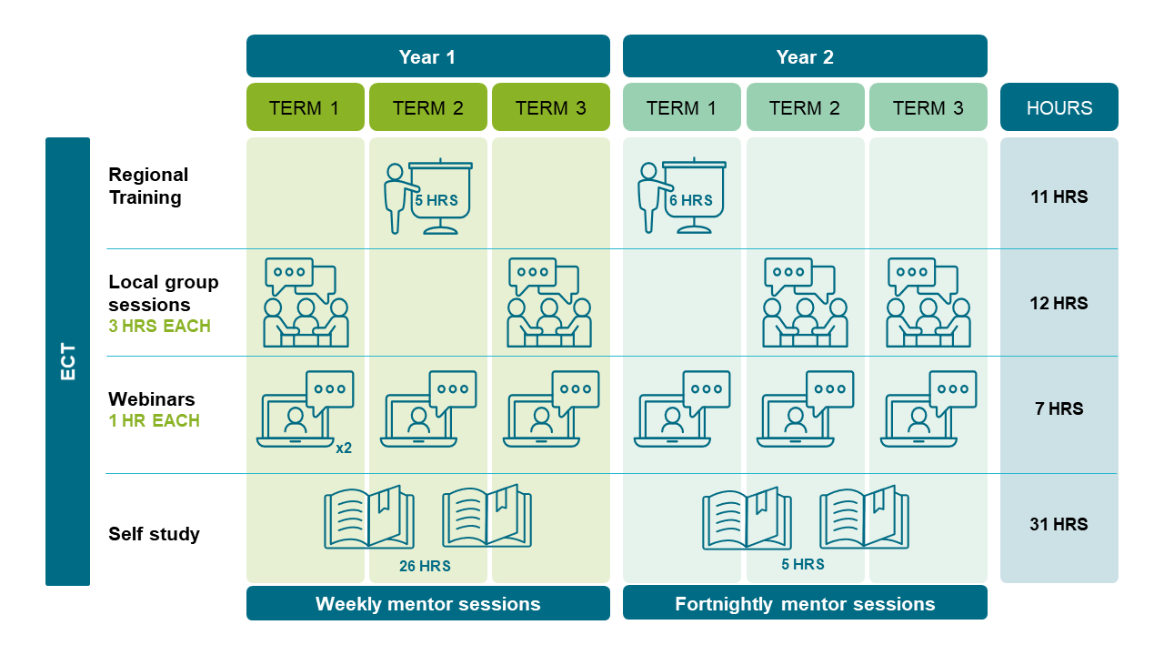

A more detailed schedule, showing training dates and session times will be available when you access the online platform, at the start of the Programme.

# 5 Your point of contact

# 6 Get started, get inspired!

Your Delivery Partner will lead you through every step of the Programme. So just keep a watch out for their emails, follow the simple instructions, and ask a question if anything is unclear.

You may want to know how you can prepare for the Programme. Our advice would be …

* [Watch the introductory webinar](https://vimeo.com/570387813/9cdc33ea9d) to get a simple overview of the course and what you will be learning.
* Remember, this Programme is here to support you! It is an entitlement, *not* a framework for assessment. So, relax, make this your own, and make the most of it.
* And don’t forget, there’s a whole world of support and inspiration out there …
  + If you haven’t already, check out your subject association. There’s an association for every teacher, whatever your subject, phase or specialism. Click [here for an introduction to a wide range of subject and phase associations](https://www.educationdevelopmenttrust.com/CMSPages/GetFile.aspx?nodeguid=506fae4b-b4d5-4dd0-96ce-0fb2e15f61ee&lang=en-GB), and [here for SEND specialist organisations](https://www.educationdevelopmenttrust.com/CMSPages/GetFile.aspx?nodeguid=f51c6347-eb3a-4c93-a897-1ee78d19321d&lang=en-GB).
  + Did you know teachers have their own Professional Body, with a Royal Charter? Visit the [Chartered College of Teaching](https://chartered.college/) and find a whole range of further support in their Early Career Hub: [earlycareer.chartered.college](https://earlycareer.chartered.college/)
  + Join our Twitter community at [@EdDevTrust_ECF](https://twitter.com/EdDevTrust_ECF)
  + Get involved, find a wealth of support, and be part of a dynamic teaching community!

**Being an early career teacher *will* be challenging, and you will make mistakes, and that is more than okay, it is necessary. That’s what any learning involves.**

!It is good to make mistakes. It is fine to miss a couple of things. It is alright not to be perfect. You are not letting anyone down. Good is good enough.!

!Remember your ‘why’, remember why you’re there! Remember the joyous interactions, not the zombie walk on a Monday morning.!

*Tom Wolstenholme, ECPDP facilitator Amjad Ali, ECPDP keynote speaker*