Early Career Professional Development Programme

**Welcome Pack for induction tutors**

National Roll Out of the  
Early Career Framework

## Handbook for Delivery Partners

# Contents

Foreword 3

1 Your role as induction tutor 4

2 Programme benefits for your school 5

2.1 Early Career Framework reforms 5

2.2 How will this Programme benefit your school? 5

3 Keeping up-to-date: the online platform 6

4 Programme snapshot 7

5 Mentors: role and training entitlement 8

6 Mentors’ use of Instructional Coaching 8

7 Mentors’ schedule 9

8 A guide to the ECT learning journey 9

8.1 What will ECTs learn? 9

8.2 What will ECTs be doing? 10

8.3 How is the learning structured for ECTs? 11

8.4 How will the Programme materials work for ECTs? 12

9 ECTs’ schedule 12

10 Using IRIS Connect 13

# Foreword

We are delighted you have joined with us to take part in the Early Career Professional Development Programme. Education Development Trust is one of six providers appointed by the Department for Education to deliver a funded package of support to early career teachers (ECTs). This package is a brand-new entitlement to strengthen ECTs’ induction experience and give them the dedicated time and support they need to develop and thrive in their chosen profession.

Education Development Trust is an international charity which aims to transform children’s life chances by improving education around the world. We have a strong track record in leading DfE-funded national initiatives, and are known as an organisation for our dedication to school-led delivery and collaborative school improvement, working *with* schools *for* schools. For this Programme, we are partnering with Teaching School Hubs, multi-academy trusts and other school-groups all across the country, as our Delivery Partners. This means that the training your ECTs and mentors receive has been designed centrally by a wide group of experts from within school and academia, and will be quality-assured nationally. However, it will be delivered by local school-based experts, who you will get to know, and who understand the unique needs of your school context. This Delivery Partner will be your main point of contact with the Programme, and will work with your school to help support your ECTs and mentors to the best of our collective ability.

We believe the Programme we have created will go a long way towards helping schools meet current challenges. And we are particularly looking to you to help us support your ECTs and mentors as they embark on this exciting new stage in their professional development.

We hope you are looking forward to this journey as much as we are.

**Matt Davis**

**UK Regional Director**

**Education Development Trust**

# 1 Your role as induction tutor

First, our sincere thanks for committing to support this Programme, in your role as induction tutor. Although you will not be responsible for delivering the Early Career Professional Development Programme in your school, we have arranged for you to have full access to all the information you might need to support the teachers taking part. This Welcome Pack includes information from both the ECT and mentor Welcome Packs, so that you have sight of:

* how the Programme is being explained to these participants, and
* what training events and other Programme components they will be asked to access.

[Watch the introductory webinar](https://vimeo.com/566990295/5f25165524) to get an overview of the Programme and your role.

We have also created a portal for induction tutors, on which we will post regular Programme updates, and where you can view all materials and resources for ECTs and mentors as they are made available throughout the course of the Programme. (Please see section 3 below.)

To support your ECTs and mentors, and make sure we as a Programme keep track of engagement, listen to feedback and continuously improve, we ask that you:

* ensure the ECTs and mentors in your school are given the allocated time to engage in and complete the Programme
* confirm on a half-termly basis that ECTs’ mentoring sessions have taken place, using a simple tick box on your portal
* take the opportunity to give us your feedback, via the surveys that will be sent to you, termly via your portal

Please note that participating in the Early Career Professional Development Programme does *not* alter your statutory duties, nor the routines of NQT assessment. As the Department for Education has set out, the Early Career Framework is *not* an assessment framework. The Early Career Professional Development Programme is firmly and exclusively about an entitlement to additional training and support, and not about an additional burden or assessment. ECTs will continue to be assessed against the Teachers’ Standards, as set out in the [Statutory Induction Guidance 2018 (publishing.service.gov.uk)](https://assets.publishing.service.gov.uk/government/uploads/system/uploads/attachment_data/file/972316/Statutory_Induction_Guidance_2021_final__002_____1___1_.pdf), revised March 2021 and in force from September 2021.

Your point of contact for any Programme queries is your Delivery Partner:

# 2 Programme benefits for your school

## 2.1 early career framework reforms

The Early Career Framework reforms are the most significant reforms to teaching in a generation. With these reforms, and together with the introduction of the new ITT Core Content Framework, the Department for Education is laying strong foundations for every novice teacher by providing three years of evidence-based professional development and support. The aim is that every new teacher will feel confident, in control and excited about their chosen career. Designed in close partnership with teachers, headteachers, academics, the Chartered College of Teaching and the Education Endowment Foundation, the ECF itself underpins what all early career teachers should be entitled to learn about and learn how to do, based on expert guidance and the best available research evidence.

## 2.2 how will this programme benefit your school?

The Early Career Professional Development Programme is designed to give schools:

* an evidence-led programme of training for your staff, designed around what really works, and how people really learn
* exceptional professional development designed for ECTs, where they will learn skills they can use straight away
* a focused development programme for mentors, with local and regional training run by expert facilitators, and peer coaching sessions with a 'buddy' mentor
* engaging and accessible online learning, alongside face-to-face and virtual training delivered by school-based experts
* peace of mind… our central and Delivery Partner teams manage all aspects of the training, freeing up in-school staff to focus elsewhere
* a training schedule carefully constructed to be compatible with school life – with the realities of a teaching timetable and school commitments in mind.



# 3 Keeping up-to-date: the online platform

For ECTs and mentors, the online platform acts as the central point for Programme updates, access to resources and webinars, and to enrol onto their training sessions. The resources and functionalities sit within five zones: Home, Progress, Learn, Events, Explore, allowing participants to:

|  |  |
| --- | --- |
| **Home** | * get the latest Programme news * pick up team messages * access their own, personalised events calendar * jump into the Block they’re working on |
| **Progress** | * check out their progress through the course materials * see how much of the current Block they’ve completed * quickly pick up from where they last finished |
| **Learn** | * find all the Blocks of core, interactive elearning, as they go live on the platform * see at a glance where they’re up to in each Block * join in Community of Practice discussion forums |
| **Events** | * see which training events are available to them * book onto selected events, choosing the date/time best suited to them |
| **Explore** | * access core guidance, e.g. ‘getting started’, wellbeing, part-time/flexible working guides * catch up on or revisit training sessions by accessing the recordings, and download webinars * discover a range of additional resources, e.g. blogs, podcasts, research digests, videos and signposting to subject/phase/specialist associations |

**Logging in for the first time**

To log into the online platform for the first time, you will need to locate your email invitation which will be sent to you in September, or when you start the Programme. Following the instructions within this email, you will be directed to the platform to set your password and log in. Should you require any technical support with the online platform, please email [ecf@educationdevelopmenttrust.com](mailto:ecf@educationdevelopmenttrust.com).

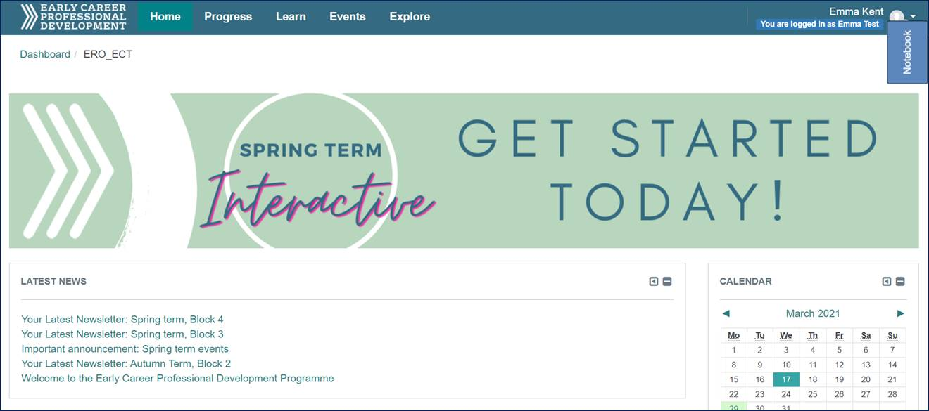

# 4 Programme snapshot

With funding from the Department for Education, we have worked with the following partners to create the Early Career Professional Development Programme:

|  |  |
| --- | --- |
| Schoolhouse outline | a broad range of school-partners, each bringing insights from particular areas of the curriculum, phases, specialisms and geographies |
|  | the Sheffield Institute of Education at Sheffield Hallam University, led by Professor Sam Twiselton, supporting the development of our curriculum and content and ensuring our whole approach is anchored in the best available evidence |
|  | the Bell Foundation, bringing expert insights into both the rich experiences and the diverse needs that EAL children bring to the classroom |
|  | video-tech experts IRIS Connect, supporting our asynchronous mentoring and coaching on this and our other teacher PD programmes nationally |

At a glance, this means we are offering schools:

|  |  |  |
| --- | --- | --- |
| DfE funding for ECTs to take 5% off-timetable in Y2 of teaching (in addition to the existing 10% in Y1), and funded time for mentors to support ECTs in Y2 |  | a solid curriculum and high-quality self-study and training materials, which: centre around the Early Career Framework; meet the Mentor and Teachers’ Standards; build on the combined expertise of our partners |
|  |  |  |
| funded training for ECTs that combines engaging, accessible online learning with both face-to-face and virtual training delivered by school-based experts |  | funded training for all mentors put forward by schools, who will benefit from local and regional sessions led by expert facilitators and peer-coaching sessions with a ‘buddy’ mentor |

The blended learning experience we are offering provides ECTs and their mentors with high-quality, evidence-informed professional development. The training schedule has been carefully constructed to not only provide the best learning experience to help ECTs to develop quickly, but to be compatible with school life – with the realities of a teaching timetable and school commitments in mind.

# 5 Mentors: role and training entitlement

The mentor role is crucial to the development of early career teachers, and of great importance to your school and local community more widely. We are very aware that many mentors will have been performing a similar function for some years now and will bring a wealth of experience to this role. For others, it will be a new challenge. Either way, the role of mentor is foundational to this Programme: it is what will drive the greatest improvements in ECTs’ knowledge, skills and confidence. Mentors will provide support and challenge and be ECTs’ chief guide through the tricky first two years in the profession.

We will train and support each mentor to develop a constructive developmental relationship with their ECT, using the principles of Instructional Coaching and harnessing their own experience and expertise. Mentors will receive a full package of training, which includes face-to-face sessions and pre-recorded webinars to ensure they are fully supported to undertake the role.

As well as having access to high-quality CPD training and materials they will also be allocated a ‘buddy’, who will be another mentor from your school, from another local school or be linked by subject/specialism. Mentors are encouraged to have regular contact with their ‘buddy’ as an opportunity to discuss progress, challenges and ideas, with time set aside in their schedule for these ‘peer-to-peer sessions’.

*Please note:* although we anticipate that the same mentor will work with the ECT for the period of the Programme, we understand that this is not always possible. If any changes do prove necessary, please let your Delivery Partner know as soon as possible.

# 6 Mentors’ use of Instructional Coaching

Instructional Coaching is a strongly evidenced model of support for improving teacher practice. In terms of impact on pupil outcomes it has a better evidence base than any other form of CPD ([Sims, 2019](https://samsims.education/2019/02/19/247/)), which is why all mentors on this Programme will use it as a model for working with their ECTs.

Instructional Coaching involves an expert teacher or practitioner working individually with an early career teacher. Not to be confused with traditional coaching and open-ended questions, Instructional Coaching is a structured cycle of **identify – learn – improve**. Crucially, Instructional Coaching involves revisiting the same specific skills, with bite-size feedback each time. Mentors won’t just tell their ECTs ***what*** they need to improve but ***how***to improve*.*

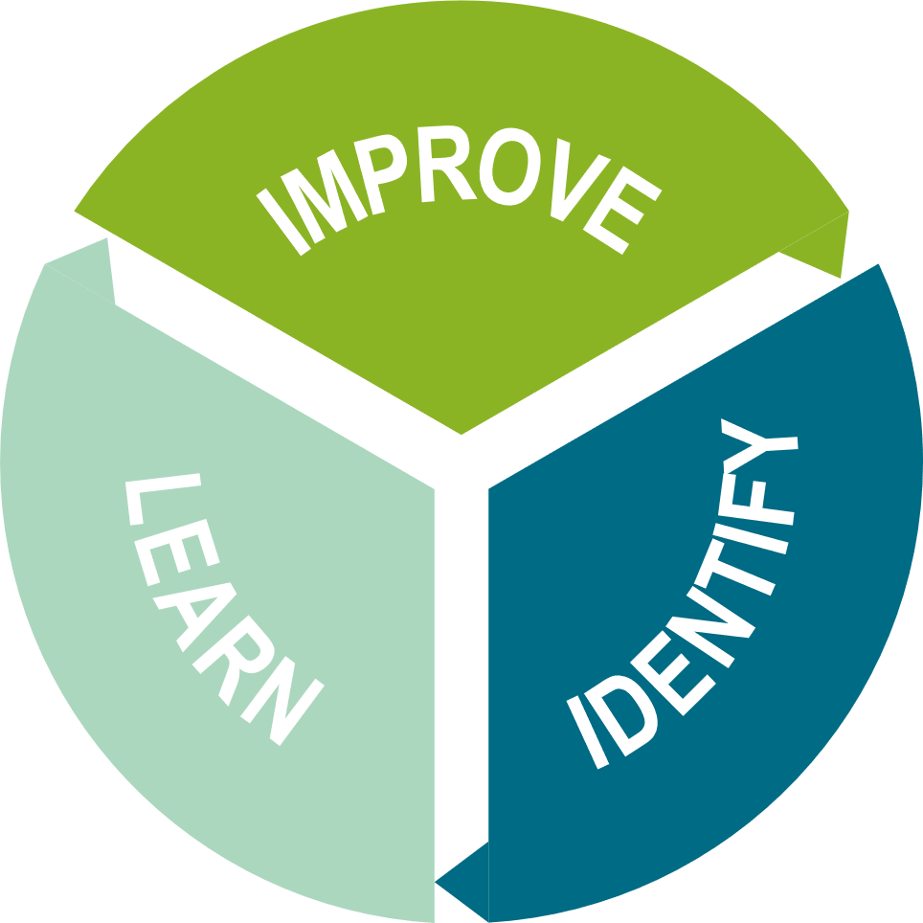

When you go back to your classroom tomorrow, what will you do differently?

Go away and do.

Monitor / review / adapt / modify / tweak

How am I going to achieve the change?

What am I going to do?

When will this be done?

Where is an example to help develop thinking further?

What am I seeing in the classroom?

What do I know we need to improve?

Where can I have the greatest impact on pupil learning?

What do I need to change to achieve this?

# 7 Mentors’ schedule

# 

A more detailed schedule, showing training dates and session times will be available for mentors when they access the online platform, at the start of the Programme.

# 8 A guide to the ECT learning journey

## 8.1 what will ects learn?

Over a carefully sequenced programme of study, ECTs will:

* build a strong understanding of the content of the Early Career Framework
* explore the evidence behind education research and implications for classroom teachers
* develop their teaching through practical ideas and exemplifications of the research in practice
* with mentors’ support – reflect on their development, identify areas of strength and areas for improvement
* engage in collaborative learning, sharing of best practice and expert challenge with a community of other early career teachers

## 8.2 what will ects be doing?

Over the two years of the Early Career Professional Development Programme, ECTs will work through 12 Blocks (modules) in total, one per half term. Each Block has been designed based on international best practice of effective professional development and includes:

* **Self-Directed Study Materials:** Interactive self-study materials (on the ECT portal of the online platform), which explain the research behind the Early Career Framework and exemplifications of what this looks like in the classroom. There is also protected time in Year 1 as part of the self-directed study for ECTs to observe mentors and other colleagues and to be observed.
* **Mentor Sessions:** One-to-one sessions with their mentor, to help translate the research into their own practice and reflect on their learning and development.
* A picture containing rectangle

  Description automatically generated**Training Sessions:** Group sessions, delivered face-to-face, to explore the Early Career Framework with their peers. These sessions will be facilitated by an expert practitioner who will extend ECTs’ thinking and support their planning by sharing practical applications of the research in their classroom.

Each Block provides ECTs with the time to:

* **Learn** the content from the Early Career Framework
* Put the learning into **practice** with suggestions for classroom practice
* **Reflect** on their professional and personal development.

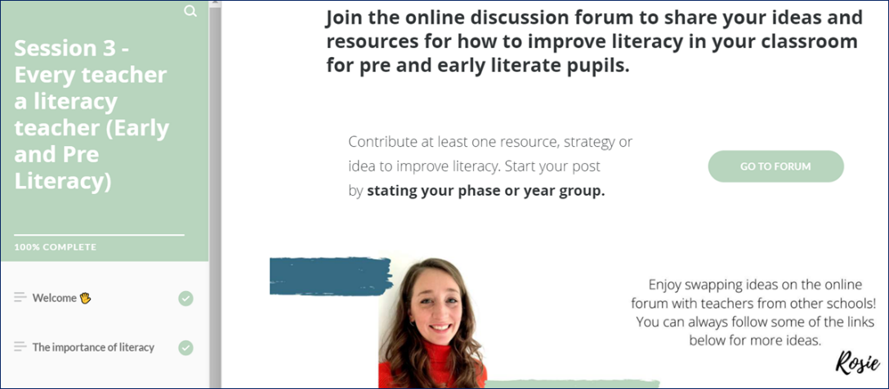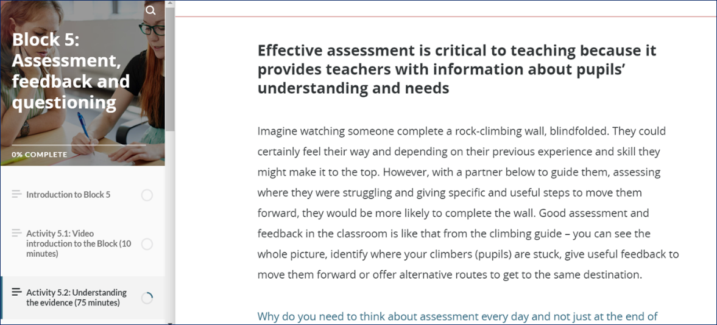

## 8.3 how is the learning structured for ects?

The Blocks have been carefully sequenced so that over the two years, ECTs will cover all statements in the Early Career Framework. The sequence builds from foundational to mastery, providing opportunities to revisit key themes and increasing in levels of complexity and depth as appropriate to their expanding experience.

Each Block starts with a ‘**why this, why now?**’ summary, which states the purpose of the Block and sets it in the context of ECTs’ experience, understanding and confidence. Many aspects of the Early Career Framework are interconnected (for example, quality assessment is not entirely distinct from quality planning or curriculum design). While we have maintained a specific deep focus for each Block, so that ECTs have enough time to understand the key aspects of those statements, the Blocks do make reference to the links between different areas. We encourage all mentors and facilitators to support the contextualisation and inter-linking as well.

|  |  |
| --- | --- |
| Year 1 Year 1 is an introduction to the key themes and statements in the Early Career Framework. The focus is on helping ECTs to establish themselves in the classroom, drawing on the best international evidence for what works in education. ECTs will work on core principles and techniques of effective teaching, including managing behaviour, lesson planning, expositions, assessment and feedback. Throughout each Block (module) they will find practical, accessible self-study activities to support their development. These will be further supplemented by regular sessions with their mentor and training sessions led by an expert practitioner. These sessions are designed to support ECTs to translate the research into their classroom, with opportunities to discuss research, observe colleagues, practise new techniques and reflect on their progress and next steps. | Year 2 The structure of the Blocks in Year 2 replicates that of Year 1. Any remaining statements from the Early Career Framework will be covered, and many of the same themes from Year 1 will be revisited in greater depth to strengthen and further ECTs’ practice. During Year 2, the focus is on mastering key ideas in the Early Career Framework. ECTs will be encouraged to reflect on the links between themes, in the light of their increasing knowledge and developing practice. They will continue to work with their mentor to reflect on the progress they have made, and by the end of the year they will identify future opportunities for development or specialisation for the next stage of their career. Training sessions provide additional support and access to a supportive peer network of other early career teachers. |
| **Block 1:** Establishing a positive climate for learning | **Block 7:** Embedding a positive climate for learning |
| **Block 2:** How pupils learn: memory & cognition | **Block 8:** How pupils learn: making it stick |
| **Block 3:** Developing effective classroom practice: teaching & adapting | **Block 9:** Enhancing classroom practice: grouping & tailoring |
| **Block 4:** The importance of subject & curriculum knowledge | **Block 10:** Revisiting the importance of subject & curriculum knowledge |
| **Block 5:** Assessment, feedback & questioning | **Block 11:** Deepening assessment, feedback & questioning |
| **Block 6:** A people profession | **Block 12:** Continuing your professional development |

[Click here for the full details of each Block](https://www.educationdevelopmenttrust.com/EducationDevelopmentTrust/files/9c/9cbc071f-8014-4907-b7ad-def6fa565f28.pdf).

Our sequence is designed based on best practice of interleaving and spaced practice for knowledge retention and recall. Each Block in Year 1 is revisited and developed in Year 2. This gives ECTs the opportunity to build on the learning from Year 1 as well as identify and recognise, through their mentor’s support, the extent to which they have mastered each aspect. Together with their ECT, mentors will celebrate their successes, recognise areas of expertise, and identify further areas and opportunities for their development.

## 8.4 how will the programme materials work for ects?

These materials are designed to work for all early career teachers regardless of subject, phase, or context. Exemplars have been drawn from a wide range of specialisms and phases and chosen specifically for their relatability. Even if ECTs do not teach pupils at the particular stage the example refers to, the point being demonstrated will still be relevant. Mentors’ own training will support them to adapt the sessions to meet their ECT’s particular needs and contextualise examples and research for the ECT’s phase or subject.

# 9 ECTs’ schedule

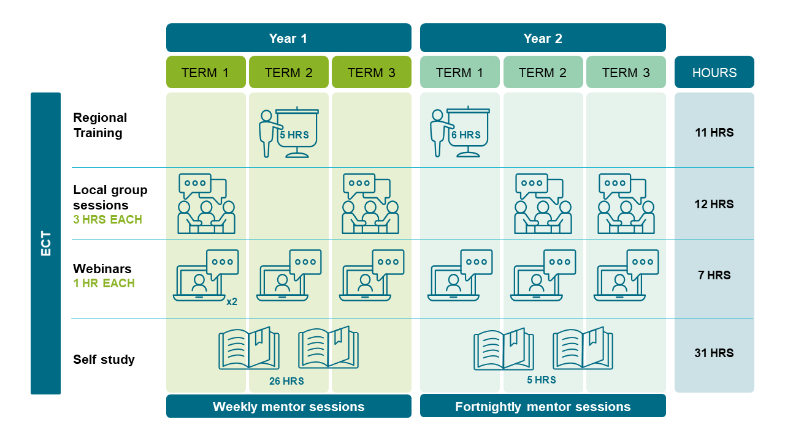

A more detailed schedule, showing training dates and session times will be available for ECTs when they access the online platform, at the start of the Programme.

# 10 Using IRIS Connect

The mentor–ECT partnership will be supported (should they wish to use it) by free access to [IRIS Connect’s](https://www.irisconnect.com/uk/) video-enabled professional learning platform. IRIS Connect allows teachers to record aspects of their classroom practice. Any videos will be securely transferred to the ECT and mentor’s personal, password-protected accounts. From there, they can reflect together on their teaching and learning, analyse focused aspects of practice, add time-stamped comments, and share in a secure cycle of feedback.

All participants as well as your school IT administrator will receive details on how to access the platform. Any technical issues should be referred to IRIS Connect by visiting [irisconnect.com/uk/support/](https://www.irisconnect.com/uk/support/) or contacting the helpdesk:

Helpdesk by phone: 0333 136 2483

Helpdesk by email: [support@irisconnect.co.uk](mailto:support@irisconnect.co.uk)

IRIS Connect is a company that specialises in using video to improve teaching and has a ‘world class secure environment’. Further information about data protection at IRIS Connect can be found at:[irisconnect.com/uk/support/security-and-safeguarding/](https://www.irisconnect.com/uk/support/security-and-safeguarding/).ECTs’ personal data, video content, and comments will be shared in the following ways during the entirety of the Programme:

* with their in-school mentor, for feedback, discussion, and development
* with the Programme team, within Education Development Trust

There is no cost to schools for providing this service and it is likely that your existing policies and parental consent cover videos being used and shared in this way. However, it is the school’s responsibility to ensure the appropriate permissions are in place. [For further details, please click here.](https://www.educationdevelopmenttrust.com/EducationDevelopmentTrust/files/9b/9bf74acf-d2f0-40a5-8281-620bda92f6d7.pdf)

[Watch this video to hear from teachers on the gains they have made using IRIS Connect.](https://irisconnect.wistia.com/medias/rgp35dia3t)

[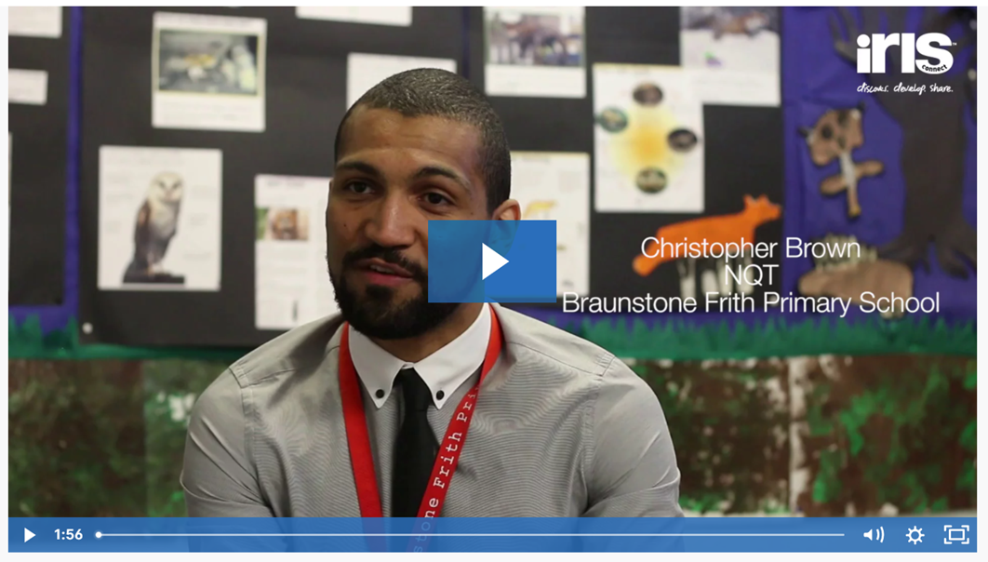](https://irisconnect.wistia.com/medias/rgp35dia3t)