Early Career Professional Development Programme

**Welcome Pack for mentors**

National Roll Out of the  
Early Career Framework

## Handbook for Delivery Partners

# Contents

Foreword 3

1 Programme snapshot 4

2 Your role as mentor 5

3 Using Instructional Coaching 6

4 Using IRIS Connect 7

5 Using the online platform 8

6 Your schedule 10

7 A guide to the ECT learning journey 10

7.1 What will ECTs learn? 10

7.2 What will ECTs be doing? 11

7.3 How is the learning structured for ECTs? 12

7.4 How will the Programme materials work for ECTs? 13

8 Making contact and getting prepared 13

# Foreword

We are delighted you have joined with us to take part in the Early Career Professional Development Programme. Education Development Trust is one of six providers appointed by the Department for Education to deliver a funded package of support to early career teachers (ECTs). This package is a brand-new entitlement to strengthen ECTs’ induction experience and give them the dedicated time and support they need to develop and thrive in their chosen profession.

Education Development Trust is an international charity which aims to transform children’s life chances by improving education around the world. We have a strong track record in leading DfE-funded national initiatives, and are known as an organisation for our dedication to school-led delivery and collaborative school improvement, working *with* schools *for* schools. For this Programme, we are partnering with Teaching School Hubs, multi-academy trusts and other school-groups all across the country, as our Delivery Partners. This means that the training you and the ECTs receive has been designed centrally by a wide group of experts from within school and academia, and will be quality-assured nationally. However, it will be delivered by local school-based experts, who you will get to know, and who understand the unique needs of the school context in which you are working. This Delivery Partner will be your main point of contact with the Programme, and will work with you, your ECT and your school more widely to help support you to the best of our collective ability.

We believe the Programme we have created will go a long way towards helping schools meet current challenges. We are looking to you to help us support all ECTs as they embark on this exciting (if daunting) new stage in their professional development. In turn, you will receive your own package of high-quality professional development, tailored to be sensitive and flexible to your workload, your expertise and your interests, and to contribute to your own career progression.

We hope you are looking forward to this journey as much as we are.

**Matt Davis**

**UK Regional Director**

**Education Development Trust**

# 1 Programme snapshot

With funding from the Department for Education, we have worked with the following partners to create the Early Career Professional Development Programme:

|  |  |
| --- | --- |
| Schoolhouse outline | a broad range of school-partners, each bringing insights from particular areas of the curriculum, phases, specialisms and geographies |
|  | the Sheffield Institute of Education at Sheffield Hallam University, led by Professor Sam Twiselton, supporting the development of our curriculum and content and ensuring our whole approach is anchored in the best available evidence |
|  | the Bell Foundation, bringing expert insights into both the rich experiences and the diverse needs that EAL children bring to the classroom |
|  | video-tech experts IRIS Connect, supporting our asynchronous mentoring and coaching on this and our other teacher PD programmes nationally |

At a glance, this means we are offering schools:

|  |  |  |
| --- | --- | --- |
| DfE funding for ECTs to take 5% off-timetable in Y2 of teaching (in addition to the existing 10% in Y1), and funded time for mentors to support ECTs in Y2 |  | a solid curriculum and high-quality self-study and training materials, which: centre around the Early Career Framework; meet the Mentor and Teachers’ Standards; build on the combined expertise of our partners |
|  |  |  |
| funded training for ECTs that combines engaging, accessible online learning with both face-to-face and virtual training delivered by school-based experts |  | funded training for all mentors put forward by schools, who will benefit from local and regional sessions led by expert facilitators and peer-coaching sessions with a ‘buddy’ mentor |

# 2 Your role as mentor

First, allow us to express our sincere thanks for taking on this role. It is one that is crucial to the development of early career teachers, and of great importance to your school and local community more widely. We are very aware that many mentors will have been performing a similar function for some years now and will bring a wealth of experience to this role. For others, it will be a new challenge! Either way, your role as mentor is foundational to this Programme: it is what will drive the greatest improvements in your ECT’s knowledge, skills, and confidence. You will provide support and challenge and be their chief guide through the tricky first two years in the profession.

Since you are at the heart of the ECF initiative, it is crucial you benefit equally, and that this becomes part of your professional development too.

* We will support you to develop a constructive developmental relationship with your ECT, using the principles of Instructional Coaching and honing as well as harnessing your own experience and expertise.
* You will receive a full package of training, which includes face-to-face events, online resources, and webinars to ensure you are fully supported to undertake the role. This will be as flexible as we can make it, to fit around your many in-school commitments and busy workload.
* You will also be allocated a ‘buddy’, who will be another mentor from your own school, from another school or be linked by subject/specialism. You will be encouraged to have regular contact as an opportunity to discuss progress, challenges and ideas, with time set aside in your schedule for these peer-to-peer sessions.

This is what some mentors said about the 2020-2021 pilot:

“I found the sessions on Instructional Coaching very helpful and detailed with practical advice I can apply as a mentor.”

“Loved it! Thank you so much. I think it is so easy to get bogged down in the day to day of teaching that CPD like this puts everything back into perspective. I am excited to continue the work with my ECT and learn alongside her.”

“The presenters were lovely. Very easy to listen to and very knowledgeable and enthusiastic about the Programme.”

“Very open forum and felt very safe for us to share ideas and speak to each other.”

# 3 Using Instructional Coaching

Instructional Coaching is a strongly evidenced model of support for improving teacher practice. In terms of impact on pupil outcomes it has a better evidence base than any other form of CPD ([Sims, 2019](https://samsims.education/2019/02/19/247/)), which is why all mentors on this Programme will use it as a model for working with their ECTs.

Instructional Coaching involves an expert teacher or practitioner working individually with novice teachers to support their learning at the start of their career. Not to be confused with traditional coaching and open-ended questions, Instructional Coaching is a structured cycle of identify – learn – improve. Crucially, Instructional Coaching involves revisiting the same specific skills, with bite-size feedback each time. You won’t just tell your *ECT what they need to improve but how to impro*ve*.*

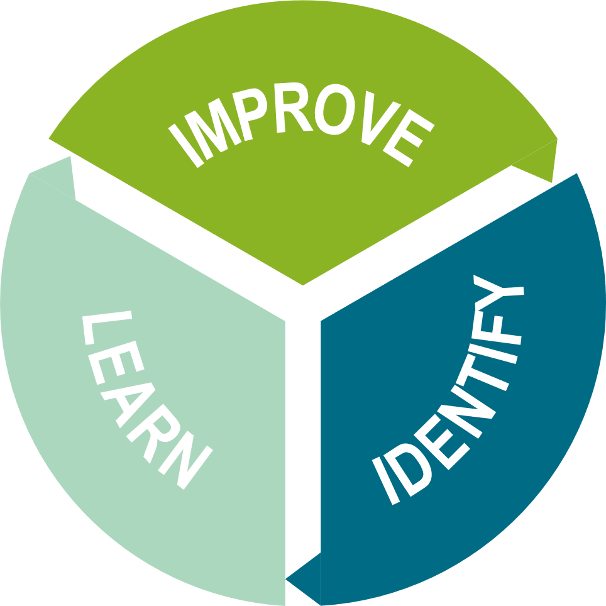

When you go back to your classroom tomorrow, what will you do differently?

Go away and do.

Monitor / review / adapt / modify / tweak

How am I going to achieve the change?

What am I going to do?

When will this be done?

Where is an example to help develop thinking further?

What am I seeing in the classroom?

What do I know we need to improve?

Where can I have the greatest impact on pupil learning?

What do I need to change to achieve this?

# 4 Using IRIS Connect

The mentor-mentee partnership will be supported – if you and your ECT wish to use it – by free access to [IRIS Connect’s](https://www.irisconnect.com/uk/) video-enabled professional learning platform. This allows you and your ECT to record aspects of your classroom practice and transfer the videos securely via your personal, password-protected accounts. From there, you can reflect on the ECT’s, your own and others’ teaching, analyse focused aspects of practice, add time-stamped comments, and share feedback with your ECT.

Both you and your school IT administrator will receive details on how to access the platform. Any technical issues should be referred to IRIS Connect by visiting [irisconnect.com/uk/support/](https://www.irisconnect.com/uk/support/) or contacting the helpdesk:

Helpdesk by phone: 0333 136 2483

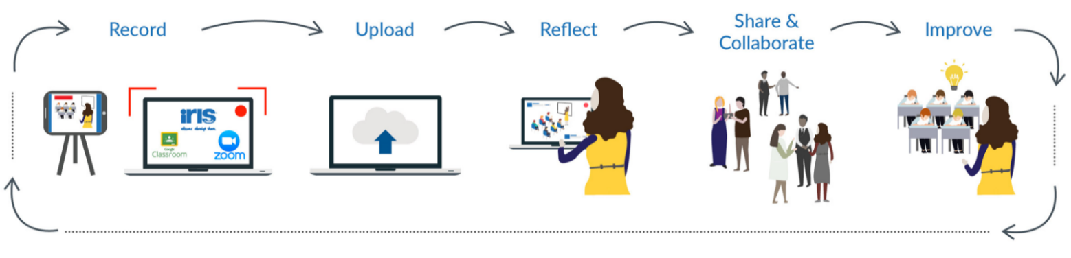Helpdesk by email: [support@irisconnect.co.uk](mailto:support@irisconnect.co.uk)

[Watch this video to hear from teachers on the gains they have made using IRIS Connect.](https://irisconnect.wistia.com/medias/rgp35dia3t)

](https://irisconnect.wistia.com/medias/rgp35dia3t)

# 5 Using the online platform

The online platform will enable your journey throughout the Programme and will act as the central point for Programme updates, access to self-study materials and webinars, and for you to enrol onto your training sessions.

The resources and functionalities sit within five zones: Home, Progress, Learn, Events, Explore, allowing you to:

|  |  |
| --- | --- |
| **Home** | * get the latest Programme news * pick up team messages * access your own, personalised events calendar * jump into the Block you’re working on |
| **Progress** | * check out your progress through the course materials * see how much of the current Block you’ve completed * quickly pick up from where you last finished |
| **Learn** | * find all the Blocks of core, interactive elearning, as they go live on the platform * see at a glance where you’re up to in each Block * join in Community of Practice discussion forums |
| **Events** | * see which training events are available to you * book onto selected events, choosing the date/time best suited to you |
| **Explore** | * access core guidance, e.g. ‘getting started’, wellbeing, part-time/flexible working guides * catch up on or revisit training sessions by accessing the recordings, and download webinars * discover a range of additional resources, e.g. blogs, podcasts, research digests, videos and signposting to subject/phase/specialist associations |

**Logging in for the first time**

To log into the online platform for the first time, you will need to locate your email invitation which will be sent to you in September, or when you start the Programme. Following the instructions within this email, you will be directed to the platform to set your password and log in. Should you require any technical support with the online platform, please email [ecf@educationdevelopmenttrust.com](mailto:ecf@educationdevelopmenttrust.com).

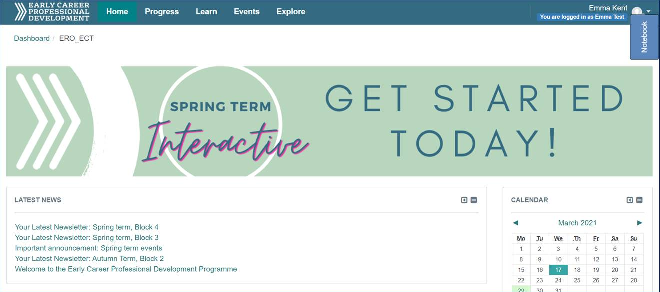

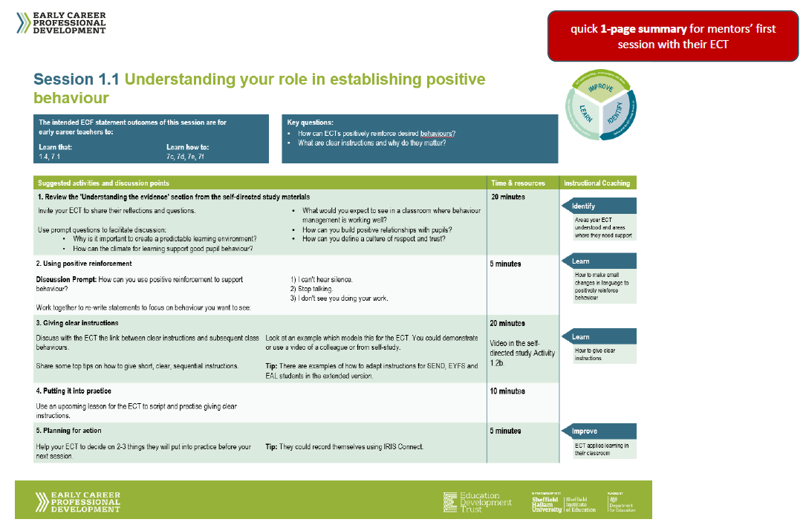Here is a sample of the kind of mentor materials you will find on the platform: *… for the mentoring sessions with your ECT:*

*… to help you contextualise the course for your ECT:*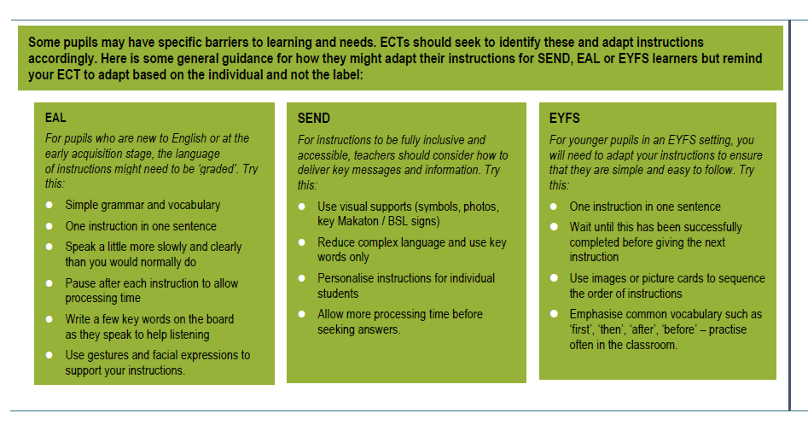

# 6 Your schedule

A more detailed schedule, showing training dates and session times will be available when you access the online platform, at the start of the Programme.

# 7 A guide to the ECT learning journey

## 7.1 what will ects learn?

Over a carefully sequenced programme of study, ECTs will:

* build a strong understanding of the content of the Early Career Framework
* explore the evidence behind education research and implications for classroom teachers
* develop their teaching through practical ideas and exemplifications of the research in practice
* with your support – reflect on their development, identify areas of strength and areas for improvement
* engage in collaborative learning, sharing of best practice and expert challenge with a community of other early career teachers

## 7.2 what will ects be doing?

Over the two years of the Early Career Professional Development Programme, ECTs will work through 12 Blocks (modules) in total, one per half term. Each Block has been designed based on international best practice of effective professional development and includes:

* **Self-Directed Study Materials:** Interactive self-study materials (on the ECT portal of the online platform), which explain the research behind the Early Career Framework and exemplifications of what this looks like in the classroom. There is also protected time in Year 1 as part of the self-directed study for ECTs to observe you and other colleagues and to be observed.
* **Mentor Sessions:** One-to-one sessions with you, to help translate the research into their own practice and reflect on their learning and development.
* A picture containing rectangle

  Description automatically generated**Training Sessions:** Group sessions, delivered face-to-face, to explore the Early Career Framework with their peers. These sessions will be facilitated by an expert practitioner who will extend ECTs’ thinking and support their planning by sharing practical applications of the research in their classroom.

Each Block provides ECTs with the time to:

* **Learn** the content from the Early Career Framework
* Put the learning into **practice** with suggestions for classroom practice
* **Reflect** on their professional and personal development.

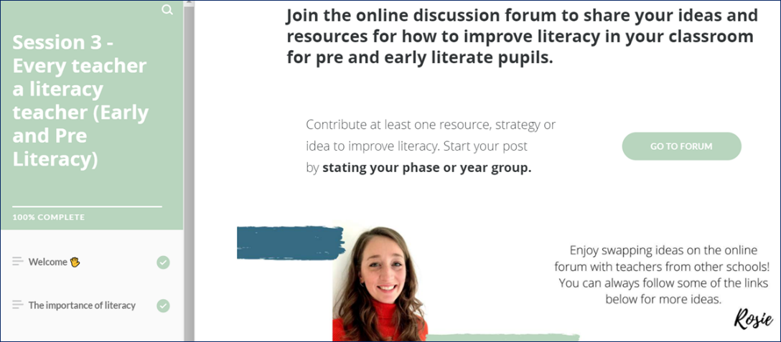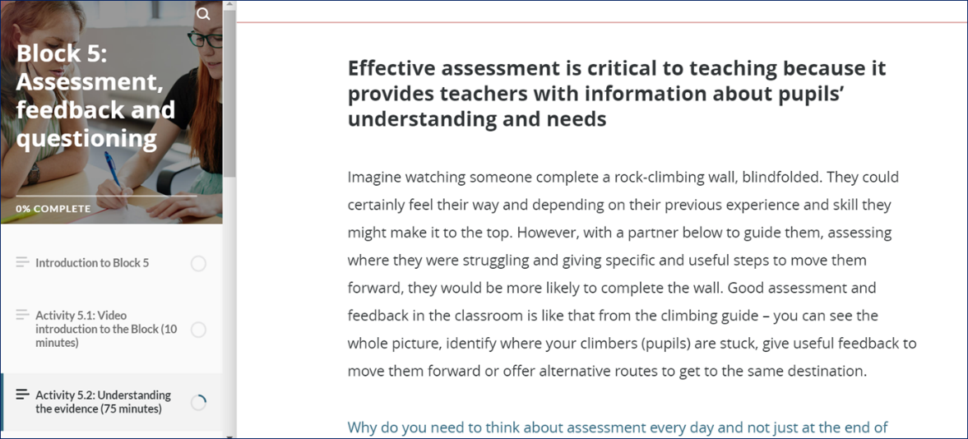

## 7.3 how is the learning structured for ects?

The Blocks have been carefully sequenced so that over the two years, ECTs will cover all statements in the Early Career Framework. The sequence builds from foundational to mastery, providing opportunities to revisit key themes and increasing in levels of complexity and depth as appropriate to their expanding experience.

Each Block starts with a ‘**why this, why now?**’ summary, which states the purpose of the Block and sets it in the context of ECTs’ experience, understanding and confidence. Many aspects of the Early Career Framework are interconnected (for example, quality assessment is not entirely distinct from quality planning or curriculum design). While we have maintained a specific deep focus for each Block, so that ECTs have enough time to understand the key aspects of those statements, the Blocks do make reference to the links between different areas. We encourage all mentors and facilitators to support the contextualisation and inter-linking as well.

|  |  |
| --- | --- |
| Year 1 Year 1 is an introduction to the key themes and statements in the Early Career Framework. The focus is on helping ECTs to establish themselves in the classroom, drawing on the best international evidence for what works in education. ECTs will work on core principles and techniques of effective teaching, including managing behaviour, lesson planning, expositions, assessment and feedback. Throughout each Block (module) they will find practical, accessible self-study activities to support their development. These will be further supplemented by regular sessions with their mentor and training sessions led by an expert practitioner. These sessions are designed to support ECTs to translate the research into their classroom, with opportunities to discuss research, observe colleagues, practise new techniques and reflect on their progress and next steps. | Year 2 The structure of the Blocks in Year 2 replicates that of Year 1. Any remaining statements from the Early Career Framework will be covered, and many of the same themes from Year 1 will be revisited in greater depth to strengthen and further ECTs’ practice. During Year 2, the focus is on mastering key ideas in the Early Career Framework. ECTs will be encouraged to reflect on the links between themes, in the light of their increasing knowledge and developing practice. They will continue to work with their mentor to reflect on the progress they have made, and by the end of the year they will identify future opportunities for development or specialisation for the next stage of their career. Training sessions provide additional support and access to a supportive peer network of other early career teachers. |
| **Block 1:** Establishing a positive climate for learning | **Block 7:** Embedding a positive climate for learning |
| **Block 2:** How pupils learn: memory & cognition | **Block 8:** How pupils learn: making it stick |
| **Block 3:** Developing effective classroom practice: teaching & adapting | **Block 9:** Enhancing classroom practice: grouping & tailoring |
| **Block 4:** The importance of subject & curriculum knowledge | **Block 10:** Revisiting the importance of subject & curriculum knowledge |
| **Block 5:** Assessment, feedback & questioning | **Block 11:** Deepening assessment, feedback & questioning |
| **Block 6:** A people profession | **Block 12:** Continuing your professional development |

[Click here for the full details of each Block.](https://www.educationdevelopmenttrust.com/EducationDevelopmentTrust/files/9c/9cbc071f-8014-4907-b7ad-def6fa565f28.pdf)

Our sequence is designed based on best practice of interleaving and spaced practice for knowledge retention and recall. Each Block in Year 1 is revisited and developed in Year 2. This gives ECTs the opportunity to build on the learning from Year 1 as well as identify and recognise, through your support, the extent to which they have mastered each aspect. Together with your ECT, you will celebrate their successes, recognise areas of expertise, and identify further areas and opportunities for their development.

## 7.4 how will the programme materials work for ects?

These materials are designed to work for all early career teachers regardless of subject, phase, or context. Exemplars have been drawn from a wide range of specialisms and phases and chosen specifically for their relatability. Even if your ECT does not teach pupils at the particular stage the example refers to, the point being demonstrated will still be relevant. Your own training will support you to adapt the sessions to meet your ECT’s particular needs and contextualise examples and research for their phase or subject.

# 8 Making contact and getting prepared

Your Delivery Partner will lead you through every step of the Programme. So just keep a watch out for their emails, follow the simple instructions, and ask a question if anything is unclear.

[Kate.frood@camden.gov.uk](mailto:Kate.frood@camden.gov.uk)

[Joe.edwards@haverstock.camden.sch.uk](mailto:Joe.edwards@haverstock.camden.sch.uk)



You may want to know how you can prepare. At the start of the Programme, you will be given clear and simple guidance to navigate all elements of the course and materials, and to help you prepare for your mentoring role, so there is no need to invest time ahead of September. If you are keen to know more now, however, you might like to:

* [Watch the introductory webinar](https://vimeo.com/566987026/23c4ce7d40) to get a simple overview of the course and what you will be doing.
* Learn a little more about the policy context of the Early Career Framework reforms, at: [Early career framework reforms: overview - GOV.UK (www.gov.uk)](https://www.gov.uk/government/publications/early-career-framework-reforms-overview/early-career-framework-reforms-overview)
* Visit [Chartered College of Teaching](https://chartered.college/) and familiarise yourself with the additional support available in their Early Career Hub: [earlycareer.chartered.college](https://earlycareer.chartered.college/)
* Join our Twitter community at [@EdDevTrust_ECF](https://twitter.com/EdDevTrust_ECF)
* And if you’re interested, take a look at Education Development Trust’s new suite of [National Professional Qualifications](https://www.educationdevelopmenttrust.com/npqs) – perhaps especially the NPQ for Leading Teacher Development, which is for teachers who have (or are aspiring to have) responsibilities for leading the development of other teachers in their school.